Flow Name: CB Automation – Slack to Client Board

Problem:
New client invoice details are communicated via Slack, but without automation this creates a risk of inconsistent intake, duplicate client records, and manual effort when updating the Client Board in Smartsheet. There is a need for a controlled, reliable mechanism to convert structured Slack messages into authoritative client records.
Solution:
This automation treats Slack as a structured intake layer and Smartsheet as the system of record. It enforces strict message formatting, performs deterministic de-duplication against the full Client Board, and creates and populates a new client row only when a unique client is detected.
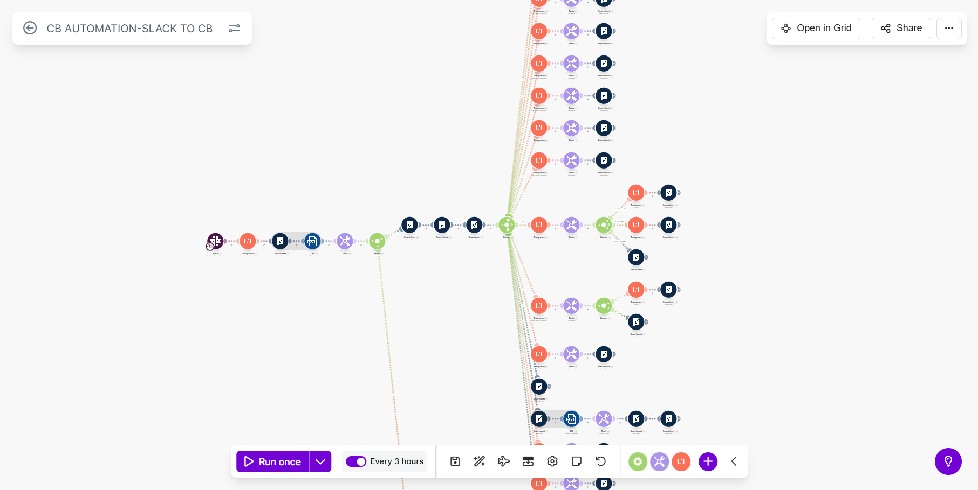
Flow Details:
Step 1: Trigger – Monitor Slack Intake Channel
The automation begins by continuously monitoring the private Slack channel new-client-invoice-update using the Watch Group Messages module. Pagination is enabled and the full message body is captured for structured parsing.
Step 2: Enforce Message Structure – Extract Name on Invoices
A strict multiline regular-expression parser extracts the Name on Invoices bullet from the Slack message. Execution stops if this field is missing, enforcing message discipline.
Step 3: Load Full Client Board from Smartsheet
The entire Client Board is retrieved in a single operation using immutable Smartsheet column IDs to maintain schema stability and avoid race conditions.
Step 4: Normalize Smartsheet Response
The raw Smartsheet API payload is converted into structured collections that Make can process natively.
Step 5: Aggregate Existing Client Data
All existing client values are aggregated into a single searchable text block to enable fast de-duplication.
Step 6: Router – De-duplication Decision
The router checks whether the extracted Name on Invoices already exists in the Client Board. If found, the flow stops. If not found, the creation path continues.
Step 7: Create New Client Row in Client Board
A new row is created at the bottom of the Client Board using column IDs. Fields are initialized according to schema requirements, ensuring structural consistency.
Step 8: Post-Creation Verification – Read Back Row
The newly created row is retrieved using its Row ID to confirm successful creation and establish a stable reference for downstream actions.
Step 9: Populate Client Board Columns from Slack Message
After verification, the automation parses the original Slack message to extract values for each supported Client Board field (such as pricing, country, billing cycle, start date, CSM, AE, and related metadata).
Each extracted value is mapped to its corresponding Smartsheet column using immutable column IDs and written into the correct cell of the newly created client row. Optional fields are handled independently so that missing values do not block execution, while present values are placed deterministically in their designated columns.
This step ensures that every client record is not only created but also fully populated with all available structured data provided at intake.
Overall Flow Summary:
This automation establishes a controlled, deterministic pipeline where Slack functions as a structured intake layer and Smartsheet functions as the system of record. By enforcing strict formatting, performing explicit de-duplication, creating schema-consistent records, and programmatically populating client fields, the flow minimizes manual effort, prevents data drift, and scales reliably as client volume grows.

